Midterm Project Proposal

By

Group 8

Allen Aguilar

Kurt Diana

Leo Jhester Dion

Melvin Dave Peralta

Michael Pinto

Regae Laroya

**News Media Online Website**

- The News Media Online Website uses web application that implements the physical newspaper showing the different kinds of news in a categorized format.It is kind of same implementation to the online news website like ABS CBN News,GMA News,Rappler and etc wherein it shows the latest news in the homepage and how it categorizing the news but we come up an original layout design and the news that we implement based on the web services that we put in the website so that the readers able to identify the differences of our website to the other popular news website.

These are the Web Services API to be implement in the News Media Online Website:

* Google News API

- it provides news sources over 30,000+ publishers from different countries that can be used in the website but we have primarily concern in local news only.The Web API key was free to access in the website.These news will be implemented in the website:

* Business
* Entertainment
* Health
* Science
* Sports
* Technology
* Headlines
* Webhose API

- it uses queries to search the specific topic of news.It has time date wherein we can select in what time has been published the news.It can also sort by any category of how the news published like VK Shares,Published,Threat Published,Rating,etc.This web service api will use for putting international news for our website.This is also free to access the Web API key.

Front-End CSS/UI Framework

* Foundation

- this CSS Framework will provide a layout of the design to be implement in the website.It has flexible design wherein it provides a template for business websites like E-Commerce,Real State or Travel,Blogs and they have News or Magazine that we can use for our website.It has also customizing parts which can be included or remove certain elements use in the website and define the size of columns,colors,font,size and etc to be download freely.

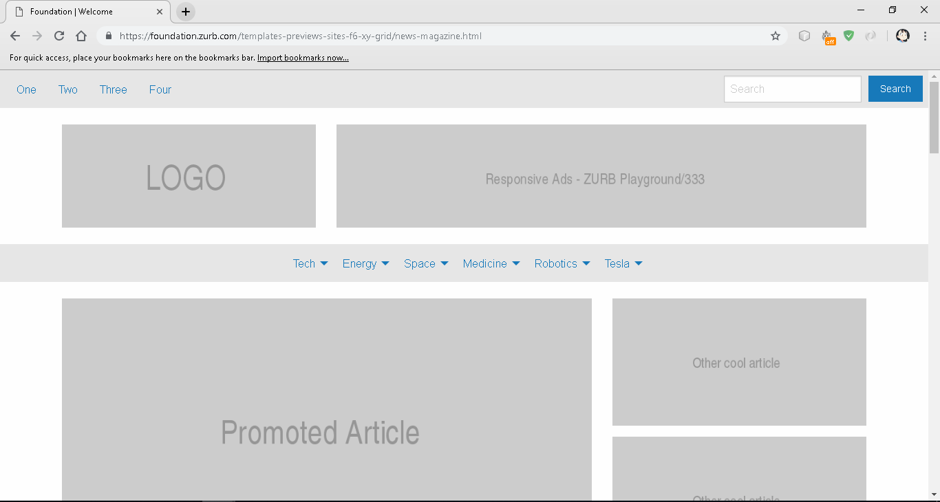Figure 1:Layout Template for the Website

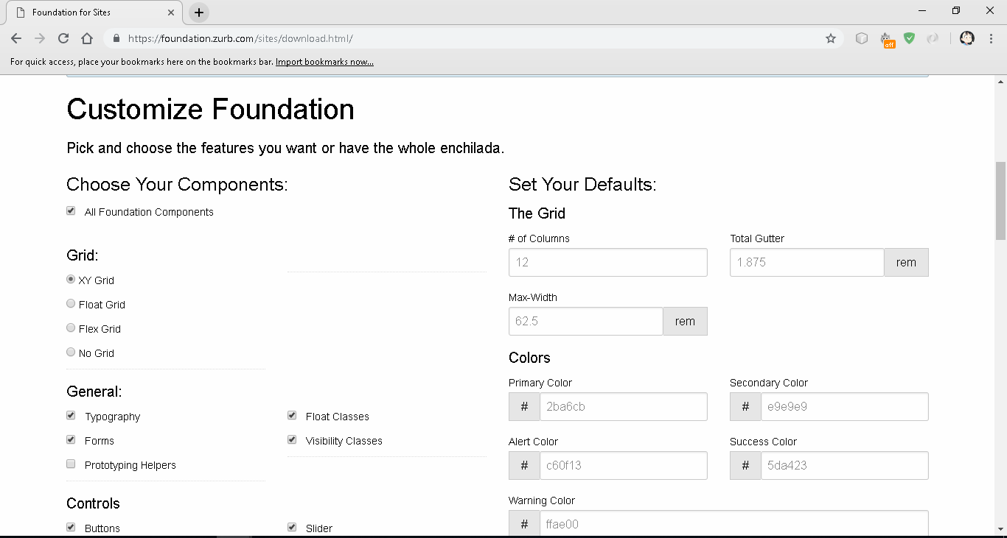Figure 2:Choices for Adding CSS elements for the Website

JavaScript library/framework

* Vue.js

-it provides documentation in how the javascript framework applies to the website to make ease to applying Web Services API to our website.It has an ability to plug this Javascript framework to the specific part of a website that needs to be need more inteactive experience to the user.Vue JS can be distributed the javascript into the different parts of the webpage and able to split it up to each having its own HTML and CSS to avoid confusion when multiple javascript applied to the website.

Website User Interface

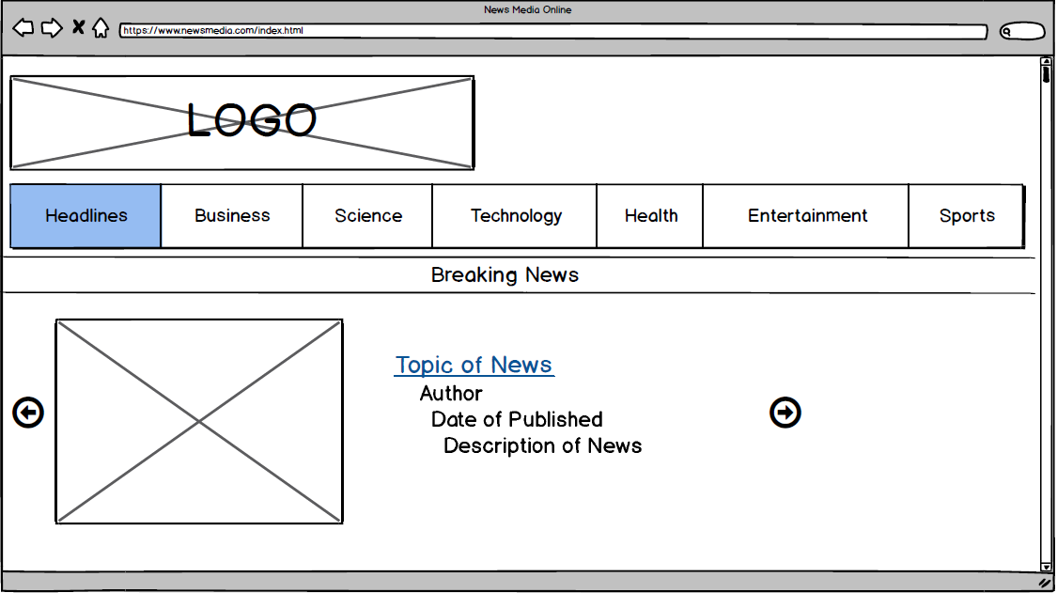Figure 1:Headline Page

This is the home page of the website wherein it shows first the current local news.It is also display the different kinds of news in the tab so that the user have an idea what other news that he/she can read more.The user can click the arrows that will shows the headlines in a slideshow format.The purpose of this headline page is to catch the attention of the user to see the current events to update him/her by pursuing her/him to read.

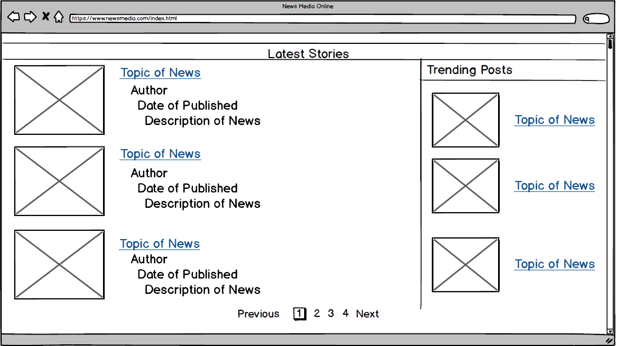Figure 2:Headline Page Part 2

This is the continuation of homepage that display the international news.It is also included the articles that are trend to the people.The user can see other topics to the next webpage of latest stories and trending posts.The purpose of this continuation of headline page is to keep also update from outside of the country to have an idea what is the situation in other country.

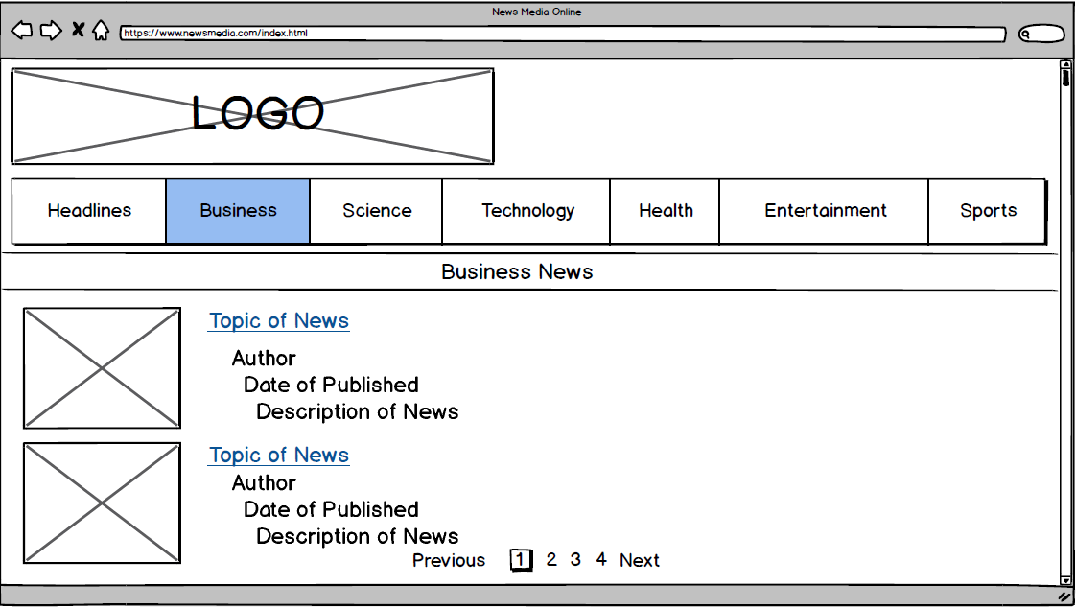Figure 3:Business Page

This is the business page showing the news about the status of different business and industries.The user can see other business news to the next page and can click the topic of news to go the content..The purpose of this business page is to keep update to the market or policy news especially to the business owners,economists,financiers,or public policy makers.

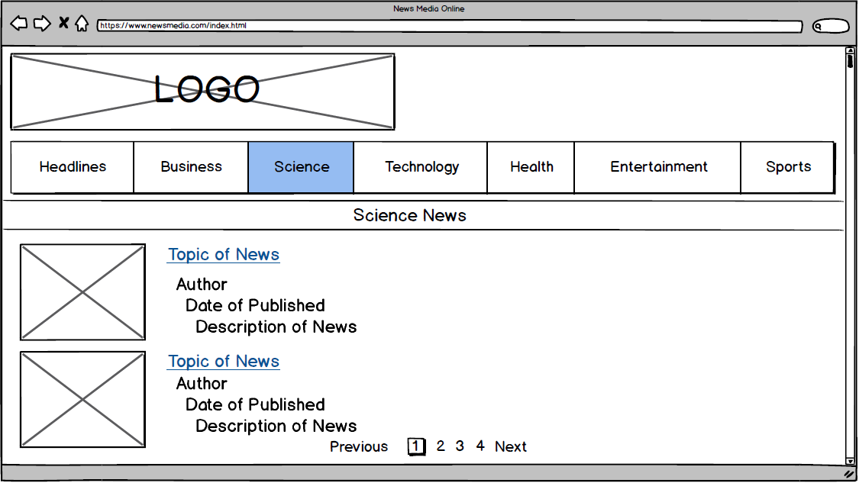Figure 4:Science Page

This is the science page showing the articles about new and scientific developments.The user can see other science news to the next page and can click the topic of news to go the content.The purpose of this science page is to keep update to the scientific journals especially to the reseachers,scientists,etc.

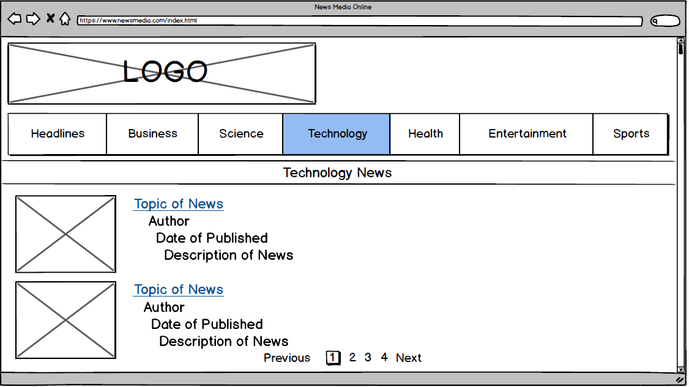Figure 5:Technology Page

This is the technology page showing the latest technology has been released to by the company.TThe user can see other technology news to the next page and can click the topic of news to go the content..The purpose of this page is know the latest technology invented or certain topic about technology.

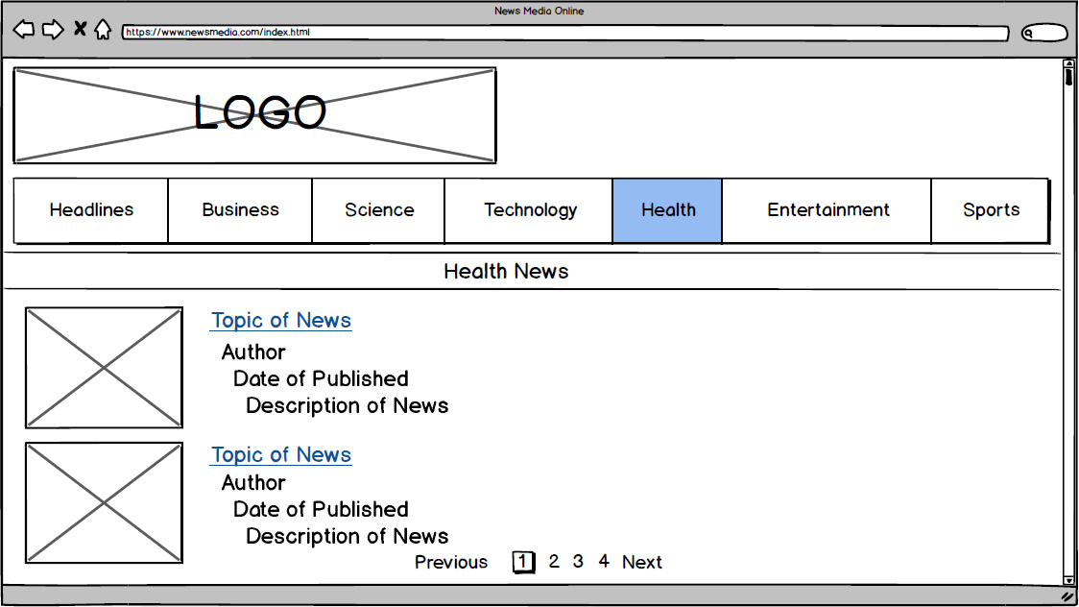Figure 6:Health Page

This is the health page showing the news concerning about aspects of health,cause and effect of the disease and healthcare.The user can see other health news to the next page and can click the topic of news to go the content.The purpose of this page is to be able to identify the concerns issues of their health.

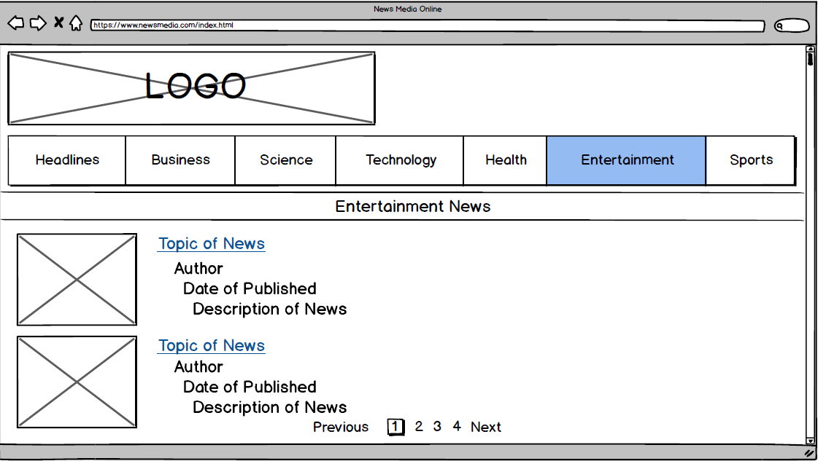Figure 7:Entertainment Page

This is the entertainment page showing information about movies.celebrities,radio,television.The user can see other entertainment news to the next page and can click the topic of news to go the content.The purpose of this page is keep update people who are interested in the tv shows,movies,celebrities and etc.

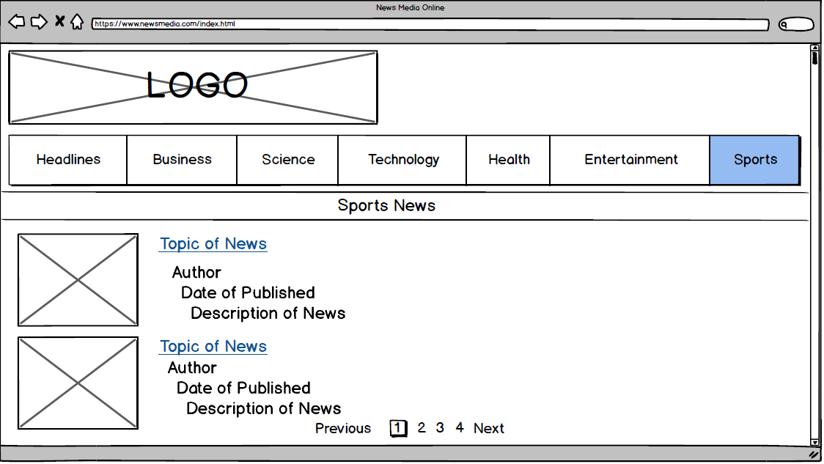Figure 8:Sports Page

This is the sports page showing the result of the national or international games and their advance reports on schedules.The user can see other sports news to the next page and can click the topic of news to go the content.The purpose of this page is to keep update the people who are fans in the sports.

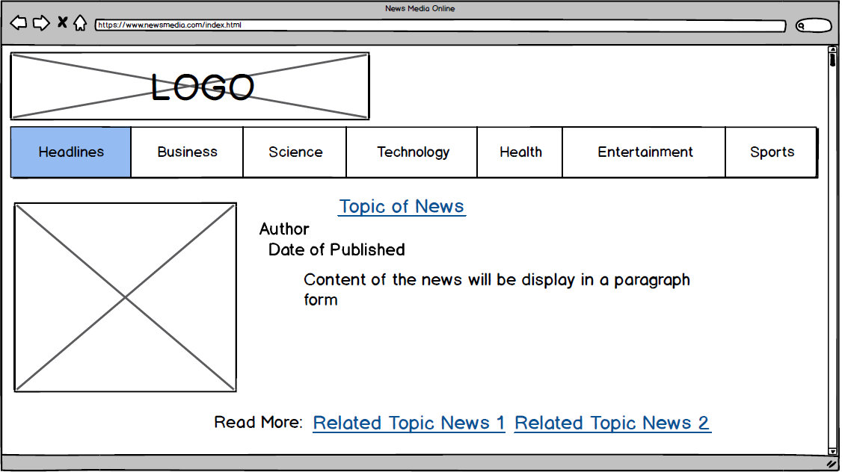Figure 9:Content of News

This is the content of news wherein the user select a specific news in any kinds of news.It will display the content of the articles including the author and date of published.And also it highlights the tab in what kind of news that the user reading.The user can also read other articles related to his/her reading by clicking the tag that the website suggesting and go to the related topic article to read by the user.The purpose of this page is to read the content of the news selected by the user and keep the user read also other related news.

References:

Sheriff, P. D., & EPS Software Corp. (n.d.). CRUD in HTML, JavaScript, and jQuery Using the Web API. Retrieved from <https://www.codemag.com/article/1601031/CRUD-in-HTML-JavaScript-and-jQuery-Using-the-Web-API>

Hannah, J. (2018, October 14). The Ultimate Guide to JavaScript Frameworks. Retrieved from <https://javascriptreport.com/the-ultimate-guide-to-javascript-frameworks/>

Vue.js. (n.d.). Retrieved from <https://vuejs.org/>

1. (2018, June 29). React vs. Angular vs. Vue: Which Should You Choose? Retrieved from <https://www.youtube.com/watch?v=xDhzYQ4VyCw>

Top 10 Front-End Frameworks of 2018. (2018, September 04). Retrieved from <https://www.keycdn.com/blog/front-end-frameworks>